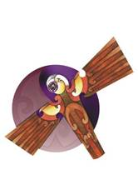
Te Wānanga Takiura o Ngā
Kura Kaupapa Māori

Pūrongo mō te Whare Pukapuka 2020

“Te hinengaro i tiritiria ki te kura wānanga”
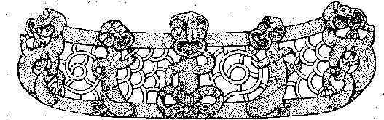

Ihirangi

4 Te Whakatakanga o Te Whare Pukapuka
6 Ngā Āheinga o te Whare Pukapuka o Te Wānanga Takiura
8 Ngā Rauemi me ngā Ratonga a Te Whare Pukapuka
10 Ngā Kohikohinga Pukapuka
12-20 Ngā Rauemi Hiko
22 Tahua Pūtea
24-32 Ngā Tatauranga mō ngā mahi Tautoko, ngā mahi Atawhai i ngā Tauira ki roto i te Whare Pukapuka
34 Te Mana Tā
36-37 Ngā Pūmaharatanga o Te Kaitiaki Pukapuka/Kairangahau

whakatakanga | mission
pukenga | skills
tūhura | to discover
putunga hōtuku | database skills
huhua noa | various information
nanaiore | endeavour
petakōki | pedagogy
epatiriomi | epistemology
onotoroni | ontology
Kupu Taka

Ngā Whakatakanga o Te Whare Pukapuka

He Kōrero Whakatakanga

Ki te arahī i te iwi ki te tūhura me te tohutohu kia tika ai te whakamahi i te Mātauranga Māori.

Ko tā te Whare Pukapuka o Te Wānanga Takiura he puna pupuri i te Mātauranga Māori hai, “Whare Pukapuka Māori hai, “Whare Kōrero Māori.”
Ko ngā mahi a te Whare Pukapuka o Te Wānanga Takiura, ko te whakaako i ngā pūkenga tūhura kōrero, ngā pūkenga ako, ngā pūkenga rangahau me ngā pūkenga aromātai hai huarahi ako mā te:
- tautoko me te āwhina i te tauira ki te tūhura i ngā kōrero me ngā mātauranga
- whakaako me te ako i ngā pūkenga tūhura kōrero, i ngā pūkenga ako, i ngā pūkenga rangahau, i ngā pūkenga aromātai, i ngā pūkenga putunga hōtuku me ngā pūkenga pai ki te kimi kōrero i runga i te ipurangi.
- whakawhanake i te mātauranga Māori o ngā tauira ma ngā Kohikohinga Pukapuka Māori ki te rangahau.
- whakatauhia he taiao ako tikanga Māori, hei tawharau ake, hei whakawhanake ake i te mātauranga Māori o te tauira.
Ko te pou tāhūhū hai whakatutuki ake i ēnei kōrero, ko te āta whakatō ki roto i ngā tauira ngā pūkenga tūhura kōrero, ki te rapu i ngā momo kōrero huhua noa kei roto i ngā pukapuka, kei roto i ngā paetukutuku kei runga hoki i te ipurangi. Ka nanaiore te Whare Pukapuka kia āhei ngā tauira ki te whakatutuki i ngā mahi a te akomanga me a rātou taumahi.
Ka mahitahi Te Whare Pukapuka i te taha o ngā Pouako me te Kaitiaki Huhua ki te whakaputa i ngā tauira o Te Wānanga Takiura ma te whakatutuki pai i ngā petakōki Māori, i ngā epatiriomi Māori me ngā onotoroni Māori.

Kupu Taka

Āheinga | capacity
tātai rauemi | stocktake
pūnaha whakahaere | management system
pakiwaitara | fiction
tūturu | non-fiction
pakipūmeka | documentary
tōrangapū | political
whai hua | to provide
ratonga | service
Te Rau Herenga o Aotearoa | Library Information Association of New Zealand
hīrangatanga | significance
patengi raraunga | databases

Ngā Āheinga o te Whare Pukapuka o te Wānanga Takiura
Ko te whakarapopototanga o te tātai rauemi a te whare pukapuka i whakaputa mai i te pūnaha whakahaere a te whare pukapuka, e kiia nei ko Musac. 10825 ngā pukapuka kei roto i te whare pukapuka kua rēhitahia ki runga i te pūnaha whakahaere a te whare pukapuka. Kīhai e taea te whakaputa he tātai mō ngā pukapuka kei roto i ia kohikohinga pukapuka, ēngari, ka āhei te pūnaha nei ki te whakaatu mai i te tātai a ngā pukapuka kōrero tūturu, a ngā pukapuka kōrero pakiwaitara rānei.
E 6344 ngā pukapuka kōrero waitara, e 4481 ngā pukapuka kōrero tūturu. Kei roto i te whare pukapuka ngā momo rauemi kōrero hai āwhina i ngā tauira me ngā kaimahi. He maha ēnei rauemi, me ōna āheinga katoa.
Kua whakatutukihia ēnei mahi mā te kohikohi i nga pukapuka e aro ana ki ngā kaupapa. Ko te kohikohinga rīpene whakaata e whakaatu ana i ngā kōrero, i ngā uiui, i ngā pakipūmeka me ngā kōrero tōrangapū e pā ana ki te Tiriti o Waitangi me tōna Tino Rangatiratanga. Koinei tētahi kohikohinga e whai hua ai ngā tauira me ngā kaimahi. Kei reira anō ngā mahi a Hine-i-Rehia me ngā rīpene whakaata e whakaatu mai ana i ngā tikanga Māori.
He kohikohinga tuhingaroa, pūrongo me ngā tuhituhinga i whakatauhia hai whakawhānui atu i te āheinga mahi rangahau a ngā tauira me ngā kaimahi.
Ka hokona ia tau e Te Wānanga Takiura i tētahi rēhita mai i a Ratonga Tono Pukapuka a Te Puna. He ratonga tēnei e whakaae ana ka āhei ngā mema ki te tono mō ngā pukapuka me ngā rauemi whare pukapuka mai i te Ratonga Tono Pukapuka a Te Puna.
He mema Te Wānanga Takiura i roto i Te Rau Herenga o Aotearoa. He mema hoki te Kaitiaki Pukapuka i roto i te Roopū Whakahau. He hoa anō i te taha o Te Rau Herenga o Aotearoa, te rōpū tautoko i ngā Kaitiaki Māori me ngā Kaimahi Pupuri Kōrero. He mema te Kaitiaki Pukapuka i roto i te roopū ā rohe mō Te Roopū Whakahau; ko Te Hikuroa tona ingoa. Ko ēnei mema e tautoko ana i te hononga o ngā Whare Pukapuka puta noa i Aotearoa. Tae atu hoki ki te Puna Mātauranga me te Whare Pukapuka a te Whare Paremata.
Ko te hīrangatanga ko ngā patengi raraunga me ngā raumei ki runga i te ipurangi he pai katoa. Ko te whakatū e wha ngā rorohiko, mō te mahi rangahau i ngā ako tōtōpū, ki roto i te whare pukapuka. He mea tautoko i ngā tauira ki te whakatutuki i ngā mahi rangahau ki runga i te ipurangi. Ka āhei rātou ki te kimi āwhina, ki te kimi whakaharatau, ki te whakamahi i ngā rorohiko i raro i te Kaitiaki Pukapuka.
Ka āhei ngā mahi mai i te whare pukapuka ki te tautoko i ngā tauira me ngā kaimahi ki te kimi kōrero me te rangahau kia ea katoa ā rātou mahi.

Kupu Taka

rīpene puoro | tape cassettes
rauemi kōrero kua tāngia | printed information
rauemi kōrero ā hiko | electronic information resources
tautono pūmanawa | computer programmes
rarangi pukapuka ā rorohiko | Online Pulic Access Catalogue
tono | request
pātengi raraunga | databases

Ngā Rauemi me ngā Ratonga a Te Whare Pukapuka

Ngā Rauemi Kōrero

Kei roto i te Whare Pukapuka o te Wānanga Takiura he rauemi kōrero kua tāngia me ngā rauemi kōrero ā rorohiko. Kei roto i ngā pukapuka, ngā pānui, ngā tuhituhinga, ngā pūrongo me ngā tuhingaroa. Ngā rauemi kōrero ā hiko nō roto i ngā rīpene whakaata, ngā rīpene pūoro, ngā kōpae whakaata, ngā tautono pūmanawa me te ipurangi.

Te Whakapā atu ki ngā Rauemi Kōrero

Mō ngā kōrero e pā ana ki ngā rauemi kōrero, ka āhei te tauira ki te whakapā atu. Mā te Kaitiaki Pukapuka o te Wānanga Takiura, e whakapā atu ki te rarangi pukapuka ā rorohiko, kei runga i ngā rorohiko o te whare pukapuka. Hai te wā ka kimi ngā tauira i ngā rauemi e hiahiatia ana e rātou, me heri mai ngā tauira i ērā rauemi ki te tēpu o te Kaitiaki Pukapuka. I reira ka āhei ngā tauira ki te tono atu, ki te kawe atu i ērā rauemi ki te kainga. Ka āhei ngā tauira ki te tono kia 5 ngā pukapuka. He tikanga tono pukapuka kei te waihangahia kia kore ai e ngaro ngā rauemi o te whare pukapuka.

Mō ngā tauira o Te Wānanga Takiura e hiahia ana ki te whakapā atu ki ngā rauemi hiko nei, kei roto i te Whare Pukapuka e 4 ngā rorohiko, e rua ngā pouaka whakaata, me tētahi mihini pūrei rīpene whakaata. He mihini pūrei rīpene pūoro hoki kei roto i te whare pukapuka. Ka āhei ngā tauira ki te whakatangi i ngā rīpene pūoro mai i te kohikohinga rīpene pūoro.

Ngā Ratonga mō ngā rauemi kōrero

Ka taea e te Kaitiaki Whare Pukapuka o te Wānanga Takiura te āwhina i ngā tauira mā te whakapā atu ki ngā kōrero kei roto i ngā pukapuka , ki runga i te ipurangi ranei mā te:

- rapu i ngā kōrero ki runga i te Rarangi Pukapuka o te Whare Pukapuka
- rapu i ngā kōrero ki roto i ngā Pātengi Raraunga
- rapu i ngā kōrero ki runga i te Ipurangi.

Mā ēnei mahi katoa, ka waia ngā tauira ki ngā momo mahi whakahaere o ia wāhanga o ēnei mahi, kia pūmau ai ēnei māramatanga ki roto i te hinengaro o ngā tauira, kia matatau ai rātou ki ngā momo mahi a te mahi rangahau. Ko tā te kaitiaki pukapuka, he whakawhanake i ērā pūkenga mā te whakaatu atu ki ngā tauira me pēhea te mahi rangahau ki runga i te rarangi pukapuka, i ngā pātengi raraunga me te ipurangi.

Ka taea anō te whakaatu me pēhea te whakapānga i ngā kōrero, arā, ma te Roopu Tiro Hinengaro o Amerika me tā rātou whakapānga APA. Ka whakaatuhia e te kaitiaki pukapuka i ngā pūmanawa rorohiko o Knightcite, Bibme me Son o te Citation Machine.
Ka whakatenatenahia te tauira, kia tuturu tana whai i ngā tikanga ā te whakapānga APA.

Ka whakaakohia ngā pūkenga ako, hei āwhina. Akene pea, he kimi, he rapu i te ipurangi mō ngā pukapuka arahī mō te tuhi i tētahi tuhingaroa, ngā momo pukapuka arahī mō ngā whakaaturanga.

whakapūmau | validate
pūkōrero | information
kōrero tōrangapū | politics
kohikohinga rīpene whakaata | collection of video cassettes
kohikohinga māheni | collection of magazines
Kupu Taka

Ngā Kohikohinga Pukapuka

Kua wāwāhia te whare pukapuka kia noho 10 ngā kohikohinga pukapuka, ma tēnā, ma tēnā kia āhei ki te whakapā atu ki ngā pukapuka mai i te rarangi pukapuka o te whare pukapuka. Mā te whakapūmau i ēnei kohikohinga pukapuka ki roto i te whare pukapuka, ka taea te kite, nō tēhea kohikohinga pukapuka ngā pukapuka. Kua whakapirihia ēnei nohonga o ngā kohikohinga pukapuka ki runga i te pūnaha MUSAC mō ia pukapuka o te whare pukapuka. Neke atu i te tekau mano ngā pukapuka kei roto i te Whare Pukapuka o Te Wānanga Takiura; kei runga i te pūnaha MUSAC ngā taunakitanga. I whakatauhia tēnei pūnaha i roto i ngā tau 2012 me te tau 2013.

Ko ngā Kohikohinga Pukapuka o te Whare Pukapuka, ko ēnei:

Kohikohinga Pukapuka Māori
Kei roto i tēnei kohikohinga pukapuka ngā mātauranga Māori, me ngā kōrero Māori. Ko te pūnaha tekau o Dewey kei te whakamahia

Kohikohinga Pukapuka Rāhui
Kei roto i tēnei kohikohinga pukapuka ngā pukapuka rāhui. Ko ngā kōrero kei roto i ngā pukapuka, he kōrero whānui, he mātauranga Māori, he pūkōrero Māori hoki.

Kohikohinga Pukapuka Tuhinga/Pūrongo
Kei roto i tēnei kohikohinga pukapuka, he tuhingaroa me ngā pūrongo mai, i ngā kaituhi Māori.

Kohikohinga Pukapuka Iwi Taketake
Kei roto i tēnei kohikohinga pukapuka ngā pūkōrero e pā ana ki ngā kōrero ā ngā iwi taketake o te Ao, ngā mahi Toi, ngā hītori me ngā kōrero tōrangapū.

Kohikohinga Pukapuka Pikitia
Kei roto i tēnei kohikohinga pukapuka ngā pukapuka tamariki, ngā pukapuka pikitia, ngā pukapuka pānui. Te katoa o ēnei pukapuka kei roto i te reo Māori

Kohikohinga Rīpene Whakaata
Kei roto i tēnei kohikohinga rīpene whakaata, he kōpae whakaata, he rīpene whakaata. Kei roto ēnei i te reo Pākehā me te reo Māori.

Kohikohinga Rīpene Pūoro
Kei roto i tēnei kohikohinga rīpene pūoro he rīpene pūoro kei roto i te reo Pākehā me te reo Māori

Kohikohinga Rauemi Kaiako
He kohikohinga pukapuka kaiako tēnei kohikohinga. Ka taea e ngā tauira tēnei kohikohinga ki te hāpai i a rātou haere ki rō kura, me te hāpai i a rātou ki te whakatutuki i ngā taumahi.

Kohikohinga Maheni
Ko tēnei kohikohinga pukapuka, he kohikohinga pukapuka e pupuri ana i ngā māheni o te Ao mātauranga, o ngā māheni pūtaiao me ngā māheni hitori.

Kohikohinga Pukapuka Kura
Ko tēnei kohikohinga pukapuka, ma ngā tamariki me ngā kaupapa whānui tonu.

rauemi hiko | online resources
patengi raraunga | databases
rarangi pukapuka | catalogue
Kupu Taka

Ngā Rauemi Hiko

Ngā Rauemi Ipurangi/Patengi Raraunga
Ka āhei te Whare Pukapuka o te Wānanga Takiura ki te tono atu mo ngā rauemi i runga i te ipurangi me ngā patengi raraunga; ka āhei anō ki te tono atu ki te Ratonga Tono Pukapuka a Te Puna (Tono Pukapuka a Te Puna).

Ka āhei ki te tono atu ki te Ratonga Tono Pukapuka a Te Puna, ki te rarangi pukapuka o te Te Puna me te rapu kōrero i te Rapunga a Te Puna. Ka taea te kimi kōrero i runga i ngā rarangi pukapuka katoa o ngā whare pukapuka katoa o Aotearoa. .
Ko te rorohiko a te kaitiaki pukapuka anake ka whakaaetia kia kuhu ki roto i te patengi raraunga o Te Puna, me te tono atu mō ngā pukapuka mai i te pūnaha VDX a Te Puna.

I tēnei wā, ko ngā ratonga o Te Puna te pātengi raraunga kei te utua e te Wānanga Takiura.
He kōrero hei tapiri ki tēnā, tokomaha ngā pātengi raraunga kei runga i te ipurangi kore utu e āhei ana Te Whare Pukapuka o te Wānanga Takiura ki te whakapā atu.

Papa Kupu Māori
He rauemi ipurangi kore utu, he papa kupu Māori i whakarewahia e te Whare Wānanga o Otakou e watea ana ki te marea. Ka āhei tēnei rauemi ki te rapu i ngā kupu Pākehā, ngā kupu Māori, ngā kīwaha, ngā whakatauki, ngā rerenga kōrero me ngā kupu arotau.

Kohikohinga Kupu Hiko o Aotearoa | New Zealand Electronic Text Collection
pūnaha | system
Te Whare Wānanga o Wikitoria | Victoria University of New Zealand

Kupu Taka
He Pātaka Kupu

He rauemi ipurangi kore utu, kei roto katoa i te reo Māori he Pātaka Kupu. Ki te kimi kupu i roto i tēnei papa kupu, me reo Māori te reo kimi, nā te mea, kei roto i te reo ngā whakautu.

He Kohikohinga Hiko Kupu o Aotearoa

Kei roto i te Kohikohinga Kupu Hiko o Aotearoa ngā kōrero e pā ana ki Aotearoa me te Moananui-a-Kiwa. Kei roto hoki ēnei kōrero i te Whare Pukapuka o Te Whare Wānanga o Wikitoria ki Poneke. Ko ngā kōrero kei roto, ko ngā kōrero kua raua atu ki runga i te rorohiko. He mea tautoko tēnei pūnaha i ngā mahi whakaako, ngā mahi ako me ngā mahi rangahau a te Whare Wānanga o Wikitoria ki Poneke. He wāhi, hai pupuri i ngā kupu taonga tawhito.

Kupu Taka

Hapori o Poronīha | Polynesian Society
hautaka | journal
orokohanga | creation
marea | public
hautaka hiko | electronic journal
rāhui | restricted access
whakapaoho | to announce, broadcast
kohikohinga niupepa | newspaper collection (Māori newspapers)

Te Hautaka o te Hapori Poronīhia

Ka mahi te Hapori o Poronīhia mō te kore utu. He roopū e noho ana ki te Whare Wānanga o Tamaki Makaurau, Aotearoa. I tīmata tēnei roopū i te tau 1892. Ko te whāinga o te Hāpori nei, ko te titiro ki ngā kōrero o mua, me ngā kōrero o naiānei e pā ana ki te iwi Māori me ngā tangata o ngā motu o te Moananui-ā-Kiwa, mo a tātou tikanga, me o tātou kawa. Mā te whakaputa o te Hautaka o te Hapori o Poronīhia e whakatutuki ai i tēnei whāinga. Ka whakaputa tēnei hautaka i ia hauwha o te tau, mai i te orokohanga mai o tēnei Hāpori, tae noa ki tēnei wa.
Nō te whakaaro nui o te Whare Pukapuka o te Whare Wānanga o Tamaki Makaurau i tū ai tēnei rauemi ipurangi mō te marea. He hautaka hiko inaiānei. Mā tēnei ka āhei te marea mai i ngā tōpito e whā o te motu me te Ao whānui te titiro ki ngā kōrero kei roto i tēnei hautaka. Ēngari he rāhui kua taka ki runga i ngā hautaka hou o te tau ki muri, me te hautaka o te tau nei. He aha ai? Kia pupuri ai i te mana o ngā kaituhi mō te kotahi tau te roa, kātahi, ka mutu. Ka tukuna te hautaka ki te rorohiko whakapaoho ai ki te Ao.

Niupepa Māori

Kei roto i te kohikohinga niupepa nei, neke atu i te 17,000 ngā whārangi niupepa, mai ngā niupepa 34. I takea mai e ngā “Niupepa 1842-1933, tētahi kohikohinga mikowhike mai i te Whare Pukapuka o Arekahānara Turnball. 70% o te kohikohinga nei, kua tuhia ki te reo Māori. E wha ngā wāhanga matua o te Kohikohinga Niupepa Māori

whakapāngataka | bibliography
ariā | abstracts/concepts
Te Whare Wānanga o Otakou | The University of Otago
aromatawai/ngia | assess
whakarewanga | to set in motion
ātikara | article
mātanga | experts

Kupu Taka
- ngā waea whakaahua o ngā pepa
- ngā kupu kua tangohia mai i ngā niupepa (he mea kimi ma te tangata)
- he whakapāngataka mā ngā kōrero mō ia niupepa
- he ariā mō ia whakaputa ki roto i te reo Pākehā
Te Puna Pupuri Kōrero a Te Whare Wānanga o Otakou

E watea ana tēnei kohikohinga tuhituhi mo te marea, nā ngā kaiako me ngā tauira o te Whare Wānanga o Otakou i kohi, i tuhi ēnei kōrero. Ka aromatawaingia e ngā mātanga o te mātauranga ēnei kōrero i mua tonu i te whakarewanga ake ki runga i te pātengi raraunga. Ka āhei te tangata ki te rapu i ngā tuhingaroa tohu paerua, ngā tuhingaroa tohu takuta, ngā ātikara rangahau, ma tēnei pātengi raraunga.
Te Puna Pupuri Kōrero o te Whare Wānanga o Wikitoria

E watea ana tēnei kohikohinga tuhituhi mo te marea. Nā ngā kaiako me ngā tauira o te Whare Wānanga o Wikitoria i kohikohi, i tuhi ēnei kōrero, ka aromatawaingia e ngā mātanga o te mātauranga. Ka āhei te tangata ki te rapu i ngā tuhingaroa tohu paerua, ngā tuhingaroa tohu takuta, ngā ātikara rangahau, mā tēnei pātengi raraunga.
Kupu Taka
marea | public
aromatawai/ngia | assess
mātanga o te mātauranga | experts of knowledge
whakarewanga | to set in motion
pātengi raraunga | databases
ātikara | articles
ahuwhenua | agriculture
maimai aroha | important obituaries
Puna Pupuri Kōrero | digital repositories
pae tukutuku | website
Taraipiunara o Waitangi | Waitangi Tribunal
Āpitihanga o te Whare Paremata | Appendices to the House of Representatives

Auckland Univeristy Digital Repository

E watea ana tēnei kohikohinga tuhituhi mo te marea. Nā ngā kaiako me ngā tauira o te Whare Wānanga o Tamaki Makaurau i kohikohi, i tuhi ēnei kōrero. Ka aromatawaingia e ngā mātanga o te mātauranga ēnei kōrero i mua tonu i te whakarewanga ake ki runga i te pātengi raraunga. Ka āhei te tangata ki te rapu i ngā tuhingaroa tohu paerua, ngā tuhingaroa tohu takuta, ngā ātikara rangahau, mā tēnei pātengi raraunga.
Te Ao Hou-The New World

Ko ngā ātikara kei roto ka pā ki te ahuwhenua. Ko ngā mahi whakarite kai, whakairo, mātauranga, ētahi atu o ngā mahi, me ngā maimai aroha. He koha ētahi o ngā tuhinga, he pūrākau hoki ngā kōrero o roto.

Ko ngā tāngata kua takoha mai he whakaaro, ko S.M(Hirini) Mead, ko Pei Te Hurunui Jones, ko Reweti Kohere, ko Joan Metge, ko J.C. Sturm, ko Kingi Ihaka, ko Maharaia Winiata, ko Turoa Royal, ko Leo Fowler, ko Hone Tuwhare, ko Barru Mitcalfe, ko Rowley Habib (Rore Hapipi), ko Patricia Grace and ko Riki Erehi, me ngā kōrero o ngā kaikōrero pūrākau pēnei i a (Mohi Turei). He whakataetae-ā-tau mō te tuhituhi Kei roto i te reo Māori me te reo Pākehā.

He tauira noa iho ēnei pātengi raraunga i ēnei rauemi mai i te ipurangi. Tokomaha ngā iwi kei a rātou he Puna Pupuri Kōrero, he pūrongo kei roto, he mātauranga, he rautaki. Kei runga i te paetukutuku o te Taraipiunara o Waitangi ngā pūrongo, kei te Puna Mātauranga, ētahi atu kōrero, pēnā i ngā Āpitihanga o te Whare Paremata, ngā Hanara, ngā Whakaahua Tawhito, ngā whakaahua hou, ngā Tuhinga a Tānara Makarini me ngā Pepa o Mua

tahua pūtea | budget
haepapa | responsibility
whakairo | to carve and or create
marau | subject
tono mō te hoko | request to purchase
takoha mai | to donate
wariu | to value
whakahiatō | to collect
Kupu Taka

Tahua Pūtea
Na te Kaitiaki Huhua te tahua pūtea o te whare pukapuka. Ko te haepapa mō te whakapau i ngā pūtea, ka noho ki roto i ēnā ringa. Ko te tahu pūtea mō te hoko pukapuka ia tau ko te tekau mano tara. Karekau he tikanga, he ture mō te hoko pukapuka i roto i te whare pukapuka. Kua taka mai ki runga i a māua ko te Kaitiaki Huhua, te whakairo tētahi tikanga ture mō te whare pukapuka. Kei ia marautanga o Te Wānanga Takiura, tāna ake tahua pūtea whare pukapuka. Kei ngā Pouako te mana ki te whakatau, me pehea te whakapau a rātou pūtea mō ta rātou ake marau. Me whakaae mai te Kaitiaki Huhua ki ngā tono mō te hoko i te tuatahi. He tahua pūtea hoki tā te whare pukapuka mō te whakahaere i tana ake tari. Kotahi mano, rima rau tara.
Kei raro iho nei ngā kōrero mō te tahua pūtea a te Whare Pukapuka:

2013 Tahua Pūtea

Tari - Whare Pukapuka $1,500
Ngā Mahi a Rehia – Whare Pukapuka $300
Te Reo Māori - Whare Pukapuka $700
Pangarau - Whare Pukapuka $300
Toi – Whare Pukapuka $300
Tikanga a Iwi – Whare Pukapuka $350
Putaiao – Whare Pukapuka $300
Puoro – Whare Pukapuka $300
Hakinakina – Whare Pukapuka $300
Hangarau – Whare Pukapuka $300
Te Aho Matua/Rangahau Uara – Whare Pukapuka $300
Rūmaki Reo – Whare Pukapuka $300
Tahua Pūtea mō te Hoko Pukapuka $10,000

Katoa
$15,250

Whakapau Pūtea mō te Marau – Whare Pukapuka $3,750

Tari/Hoko Pukapuka – Whare Pukapuka $11,500

Tahua Pūtea mō te Hoko Pukapuka $13,750 (@110 per student)

Whakahiatō i te Hoko Pukapuka mō te Tau 2020

He kōrero mō te pai o te tiaki pūtea mō te hoko pukapuka. I takoha mai ētahi o ngā whare pukapuka i a rātou pukapuka ki te Whare Pukapuka o te Wānanga Takiura. He waimarie te Whare Pukapuka o te Wānanga Takiura. E whitu ngā kape o te pukapuka Ngā Iwi o Tainui i takohatia mai. Ko te wariu, ko te $54.80. E rima ngā kape o ngā Pakanga Pū i whakawhiwhia. Ko te wariu, ko te $58.70. I takohatia mai e tētahi, he pouaka whakaata. Ko te wariu $200 – $300. I tēnei wā neke atu i te $2,000 – $3,000 te wariu o ngā pukapuka kua takohatia mai ki te Whare Pukapuka o te Wānanga Takiura.
Kei te tōmuri ngā mahi whakararangi pukapuka, nā te huhua noa o ngā pukapuka hou.

Kupu Taka
tatauranga | statistics
mahi arahī | guidance
ratonga | service
patengi raraunga | databases

Ngā Tatauranga mō ngā Mahi Tautoko me ngā Mahi Arahī
.
Tauira Tuatahi
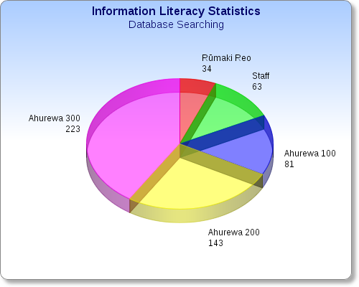
Ngā Tatauranga mō te Whakamahi i ngā Pātengi Raraunga
=15%
=12%
=6%
=41%

Ko ēnei te rahi o ngā tauira me ngā kaimahi e hiahia ana ki te whakamahi i ngā pātengi raraunga: 544
Total number of times students and staff have asked for guidance in Databases searches: 544
=26%

Kei roto i tēnei tauira, e whakaatu mai ana i ngā tatauranga i ngā mahi tautoko, i ngā mahi arahī ā ngā ratonga i tau atu ki runga i ngā kaimahi me ngā tauira o te Wānanga Takiura mō te whakamahi i ngā pātengi raraunga. Mā tēnei ka tino piki ngā pūkenga mō te kimi kōrero.

Kupu Taka

tatauranga | statistics
taunaki | to support
ratonga | service
whakapānga APA | APA referencing

Tauira Tuarua
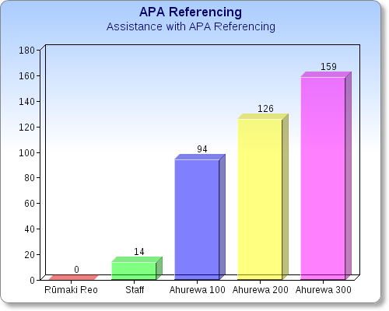
.
Te rahi o ngā tangata kua āwhinatia: 393
Whakapānga APA: Ngā mahi āwhina whakapānga.
=40%
=32%
=24%
=4%
Total requests for assistance: 393

Kei roto i tēnei tauira, he whakaatu mai i ngā tatauranga hai taunaki mō ngā mahi āwhina me ngā ratonga ki ngā tauira o te Wānanga Takiura e pā ana ki te whakapānga APA. Ahakoa tēnā, he kohinga kōrero anō e whakaatu ana i te rahi o ngā tauira kei te whakamahi i te pūnaha APA.

Kua kohia ēnei kōrero hei whakaaatu i ngā momo whika katoa o ngā marama e rua.

Kupu Taka
mahi tautoko | to assist

Tauira Tuatoru
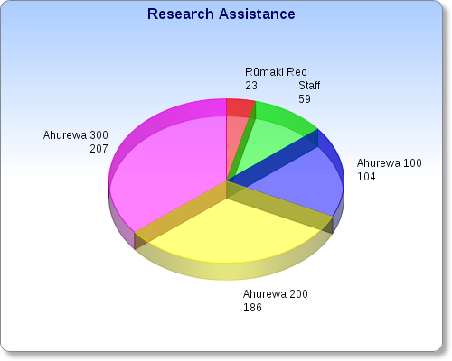
Mahi Rangahau
Total requests for assistance: 579
Te rahi o ngā tangata kua āwhinatia: 579

=4%
=10%

=36%

=18%

=32%

Kei roto i tēnei tauira tuatoru, he tatauranga e whakaatu ana i ngā ratonga me ngā mahi tautoko i ngā tauira o te Wānanga Takiura mai i roto i ngā mahi rangahau. He kohinga kōrero e whakaatu ana i te rahi o ngā tauira e rangahau ana.

Kupu Taka

tauira tuawhā | fourth graph
tatauranga | statistics
arahī | guide
ratonga | service

Tauira Tuawhā

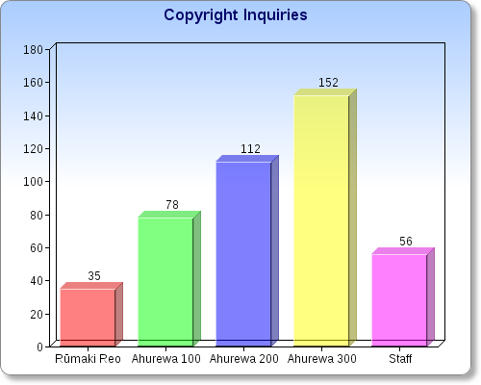
Ngā Ui Mana Tā
Te rahi o ngā uinga: 433

=35%

=26%

=18%

=13%

=8%

Kei roto tēnei tauira tuawhā, he whakaatu atu i ngā tatauranga mō ngā mahi arahī, ngā mahi tautoko, ngā ratonga katoa ki ngā tauira o te Wānanga Takiura.

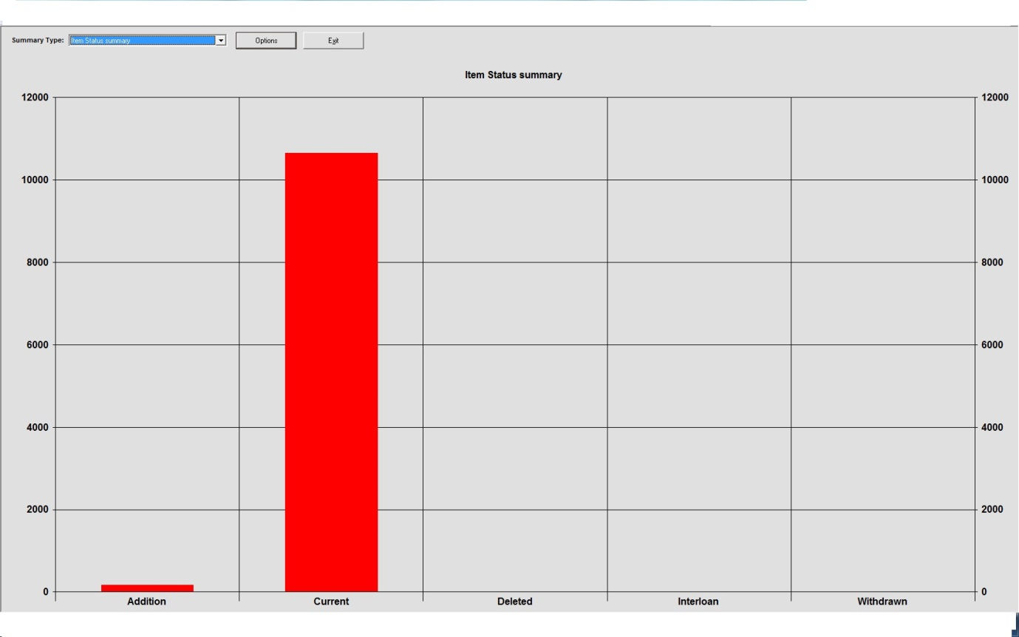
Kupu Taka

tono | request
tatauranga | statistics
whakapānga | reference

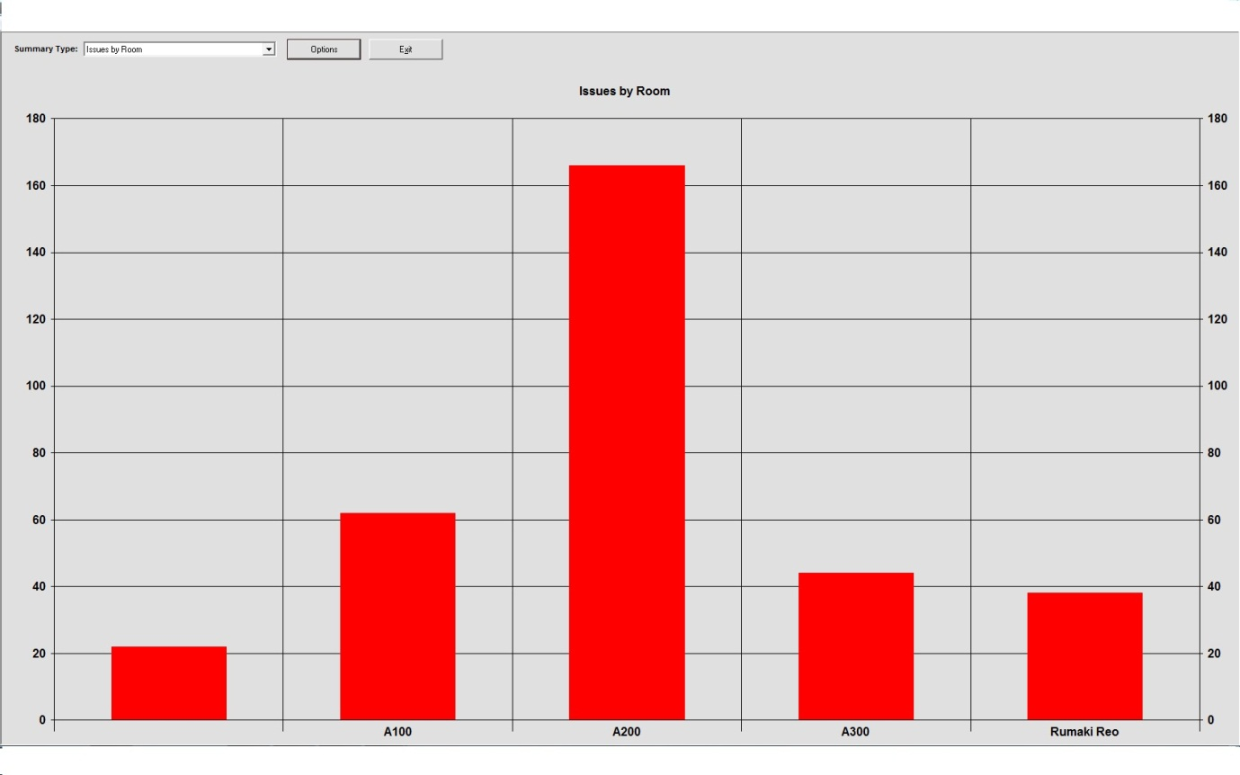
Tauira Tuarima
Kei roto i tēnei tauira tuarima he whakaaturanga i te rahi o ngā pukapuka kua tono mai ngā tauira i roto i ngā marama e rua. Ko te akomanga e kaha ana nei ki te tono mai mō ngā pukapuka, ko te Ahurewa 200. Kātahi, ko te Ahurewa 100, ka rua, ko te Ahurewa 300 ka toru ko te Rūmaki Reo me ngā Kaiako i te mutunga.

Ko te Whakahiato o ngā Tatauranga
Ahakoa, kāore e kaha ana te tono pukapuka a te Ahurewa 300, he kaha tonu rātou i roto i ngā tatauranga o mua mō te pānui kōrero, ngā mahi rangahau, ngā mahi whakapānga me ngā pātai mō te ture mana tā.

Kupu Taka
whiti kōrero | chapter (of a book)
ātikara | article
hautaka | journal
whakapānga | reference
kiriata | video
paetukutuku | web page
CLNZ | Copyright Licensing New Zealand

Te Mana ki te Tā
Kei te mārama ngā tauira me ngā kaimahi o te Wānanga Takiura, ka taea e rātou te kape, te tā rua rānei i ngā kōrero ma a rātou ake mahi rangahau. Engari ka 10% noaiho o te pukapuka ka āhei rātou ki te kape. Ko tētahi whiti kōrero o te pukapuka, ko tētahi ātikara mai i te maheni,ko te niupepa, hautaka rānei.

Ka pau ana te raihana mana tā, ka āhei tonu te tauira, te kaimahi rānei ki te kape, engari, kia kotahi te kape ma ia tangata.

Ko te nuinga o ngā kōrero kei runga i te ipurangi, he mana tā kei runga i ngā kōrero. Me te tiaki ēnei kōrero mai i te ipurangi. He rāhui kei ētahi, ko ēnei e whai ake nei:
- Ka āhei ngā tauira me ngā kaimahi ki te whakamahi i ngā kōrero mō tā rātou ake mahi ako.
- Kāore e āhei te tauira me te kaimahi ki te whakamahi i ia kupu o ēnei kōrero. He mahi tahae, he mahi whanako tēnā.
- Me whakapānga ngā tauira me ngā kaimahi i ngā kōrero katoa
- Ka āhei ngā tauira me nga kaimahi ki te whakamahi i ngā kōrero kua whakamanahia, ki te pātai atu rānei mō te whakaaetanga o ngā tangata nā rātou ērā kōrero. Ka tupono ki ētahi kōrero kua whai raihana (pēnā i te Creative Commons Raihana) me ngā kōrero kei waho tonu i te te ture mana tā, ka āhei ki te kape.
Ko ngā kiriata me ngā waiata ka tiakina mai i ngā paetukutuku whai mana ki te ture. Ki te kore e mau i ngā paetukutuku tēnei mana, he mahi whanako, he mahi tahae te tiki atu.
Kei te utu Te Wānanga Takiura o Ngā Kura Kaupapa Māori o Aotearoa he utu a tau ki te Mana Tā Raihana Aotearoa. Ko rātou e tuku mai ana i te raihana mana tā. Ko te utu mō te tīwhikete mana tā mo te tau 2013 ko te $855.60.

Anei ngā hua kei raro i te raihana mana tā o Mana Tā Raihana Aotearoa (CLNZ).
- 10%, tētahi whitinga kōrero, ka āhei ki te kape mai i tētahi pukapuka.
- Ka āhei ki te kape kia 15 ngā whārangi mai i tētahi kohinga kōrero (ngā pakiwaitara, rotarota)
- Ka āhei ki te kape i tētah ātikara mai i tētahi maheni, tētahi hautaka rānei.
- Ka āhei ki te kape te katoa o tētahi tuhinga, ēngari, ka mutu te tā mai i taua kōrero, kāore e āhei ki te hoko. Me whai whakaaetanga mai i te CLNZ i te tuatahi.
He aha ngā mea kāore i raro i te raihana?

- Ngā kōrero mai i te ipurangi
- Ngā waiata kua tāngia ki te pepa.
- Ngā hautaka whare
- Ngā tuhingaroa
- Ngā mahi toi
- Ngā mapi
- Ngā rauemi kua whai mana ki te kape, kua whai mana hoki te kamupene tā ki te kape i aua kōrero.

He aha ngā mea ka āhei ki te kape?

- Ngā Pukapuka
- Ngā Maheni/Hautaka
- Ngā Niupepa
- Ngā Mahi Toi kei roto i ngā pukapuka

Kupu Taka
pūnaha | systems
Pūmaharatanga | reflection
marika/tia | to be absolute in a statement
ratonga | service
rautaki hoko pukapuka | strategic purchasing
Te Whainga Roa | Long Term
Ōhakī | Statement of Purpose

Ngā Pūmaharatanga o te Kaitiaki Pukapuka/Kairanghau

Kei te rere haere ngā pūnaha me ngā mahi whakahaere o te whare pukapuka. Kua pai ake ngā mahi whakararangi pukapuka me ētahi atu o ngā raumei mō ngā kohikohinga o te whare pukapuka. Kei te rere pai te mahi. Kei te whai atu i te kounga o te mahi. Kua whakatau marikatia ngā kohikohinga pukapuka o te whare pukapuka, kua rahi ake ai ngā pukapuka. Ko ngā ratonga o te whare pukapuka, kei te mahi tonu, ahakoa te tokoiti, te tokomaha hoki o ngā tauira ka tae mai ki te whare pukapuka.
Ngā Whainga Poto o te Whare Pukapuka

Kia whakapai ake i ngā kohikohinga pukapuka Māori kei roto i te whare pukapuka, mā te whai i tētahi rautaki hoko pukapuka ma ngā akoranga. Ko te whakamahi i ngā pūkenga ki te hāpai, ki te whakawhanake i ngā ratonga me ngā pūkenga rangahau a ngā tangata e mene mai ana ki te whare pukapuka.

Te Whainga Roa o te Whare Pukapuka

Kia whakarahi ake i te whare pukapuka me ōna āheinga. Kia tū tōtika hai whare pukapuka mātauranga Māori. He mea kāmehameha, hei tauira mō ngā whare pukapuka katoa. Kia whakapakari ake i ngā tauira i roto i ngā pūkenga whare pukapuka. Kia āhei rātou ki te noho motuhake ki te ako, ki te rangahau.

Ko te Ōhakī

Kia noho tiketike tonu ngā mahi a te whare pukapuka, hei whakangungu i ngā tikanga Māori, me te whai i te ito o te whakaaro o ngā tikanga me ngā kawa. Ko te whakawhānake i Te Whare Pukapuka Mātauranga Māori, kia teitei tonu ki roto i te ao Whare Wānanga. Kia mahitahi i te taha o ngā kaimahi me ngā tauira o Te Wānanga Takiura. Kia hono tonu ki te Roopu Whakahau me Te Hikuroa (Ngā Kaitiaki Pukapuka Māori, me ngā Kairangahau Māori).

Whakahiato

He whakahiatō i tēnei pūrongo kia āhei Te Whare Pukapuka o te Wānanga Takiura me āna mahi i roto i ngā tau ki muri. He whakaaturanga tēnei pūrongo i ngā mahi katoa o te whare pukapuka, ōna wawata katoa, tōna hīrangatanga kia teitei ngā mahi a te Wānanga Takiura.

Whakakapi

Kua whakataungia tēnei pūrongo whakarapopoto mō ngā tau ki muri. Ko ngā kōrero kei roto i te pūrongo nei, kua whakaritea kētia ma te Kaitiaki Huhua o te Wānanga Takiura o Ngā Kura Kaupapa Māori o Aotearoa. Tae atu hoki ki ngā tangata i tua atu i te Kaitiaki Huhua e hiahia ana ki te pānui i ēnei kōrero.

